

“E Cops”

## Java Project

**SWE204 – Programming in Java**

**Submitted to**:

Prof. Chiranji Lal Chowdhary

School of ITE

**Submitted by:**

**14MSE0385 B.Lokesh**

**14MSE0294 J.Gowtham**

**14MSE0029 C.Manideep**



**CERTIFICATE**

This is to certify that **B.Lokesh(14MSE0385)** and **J.Gowtham(14MSE0294) and C.Manideep(14MSE0029)** have successfully completed this project work under my guidance during the academic Fall Semester July-November 2015.

This project work was a necessary requirement for the Project-based Learning Course of “SWE204- Programming in Java” subject in School of Information Technology, VIT University Vellore.

Date and Place: Prof. Chiranji Lal Chowdhary

**ACKNOWLEDGEMENTS**

We would like to thank Prof. Chiranji Lal Chowdhary (VIT University, Vellore) for providing us complete guidance and help throughout the project and for his sustained encouragement and support.

We are also grateful to our beloved Chancellor Shri G. Viswanathan for giving us an opportunity to study in such a glorious University.

Special thanks, who helped us to complete the project in every way.

Place: B.Lokesh [14MSE0385]

Date: J.Gowtham [14MSE0294]

C.Manideep [14MSE0029]

**Table of Contents**

**Chapter No.** **Title** **Page No.**

Certificate 2

Acknowledgements 3

1. INTRODUCTION 5
2. DESCRIPTION 6
3. SOURCE CODE 8
4. SNAP SHOTS / OUTPUT 42

1. RESULT 50

**Introduction**

**OBJECTIVE:**

Generally many crimes seen by the public will not reach to the police due to many reasons like fear, Lack of time, Ignorance. Due to this reason many cases are not even reaching the police station. Though some cases are registered they are not investigated properly due to lack of evidences and Cooperation of the public. This software helps the public to report about the crimes to the police with out any fear in correct time. This is helpful to police in solving the cases .This is also helpful for higher authorities of police to have an overview about the progress of the investigation.

ECOPS is an online reporting service to which the internet user can report crimes committed on or through the Internet. The impact of IT and communications is traversing at a fast pace. As information for the department is crucial, an enterprise IT tool for enhancing the performance of the police officials became necessary called ECOPS or E-Computerized Operations for Police Services, the main purpose is to maintain information, monitor and enhance the performance of the department.

The focus of ECOPS is to computerize the activities of controlling crime, administration and support services across the state in an integrated fashion so as to enable the division heads and senior officers to obtain the relevant information. Besides, it is also envisaged to reduce dependence on paper and help in automatic maintenance of registers and generation of reports, data analysis, better planning and coordination, speedy detection of crimes and monitoring the prosecutions.

**DESCRIPTION**

**SCOPE OF THE PROJECT:**

An online solution is very useful as the solution is inherently distributive. This distributive characteristic of the online solution helps in getting the different police stations to share information and get in contact with one another. With respect to ECOPS, going forward, the aim is to develop new technologies that include designing new techniques to fight crime and improve criminal justice. Plans are afoot to embed multi-purpose technologies such as traffic management, mobile data techniques, warrants, personnel scheduling, gang activity analysis, field reporting, human resource development of police personnel, etc.

For the police, initiatives such as ECOPS are designed to improve their long-term relations with the citizens due to effective feedback and faster exchange of critical information between various departments and police stations.

**EXISTING SYSTEM:**

The normal public in India are afraid to give an complaint in police station because they are filled with a false fear about the police department. An online complaint registering system will solve the fears of public and will also help the police department in catching criminals.

**PROPOSED SYSTEM:**

An online solution is very useful as the solution is inherently distributive. This distributive characteristic of the online solution helps in getting the different police stations to share information and get in contact with one another. Information about the criminals and the police is also made available to the people in this system.

**Our work is divided into 2 modules:**

* **User**
* **Police**

**User:**

User can send complaints to police in any issue of disturbance or problem. He can verify the status of the registered complaint. He can do his work only when he logs in with correct username or password. If he want to create any new account, he can even register himself through Registration Form. The user can check status by complaint id only.

**Police:**

Basing on the complaints given by the public, police can view them and take appropriate action timely. The police has to login with their account to view the complaints and to send the status of the complaints to the users. They can update the status of the complaint basing on the progress of investigation. Police also can register if the person is new to department.

**Syllabus Topics used in Project Work:**

* Extending Frames from Applets
* Using setBounds()
* Usage of **static** keyword
* Using simple coding to show complex output

**Source Code**

import java.awt.*;

import java.awt.event.*;

import java.applet.*;

/*<applet code="MyWork" width=1350 height=650>

</applet>

*/

public class MyWork extends Applet implements ActionListener

{

Frame f1;

List l1;

Label la1;

public void init()

{

setLayout(null);

f1=new LoginFrame();

l1=new List(4,false);

l1.add("Home");

l1.add("Login");

l1.add("Legal");

l1.add("Contact Us");

add(l1);

l1.setBounds(40,150,75,100);

l1.addActionListener(this);

}

public void actionPerformed(ActionEvent e)

{

repaint();

}

public void paint(Graphics g)

{

String val="E Cops";

setBackground(Color.lightGray);

g.setFont(new Font("Old English Text MT",Font.BOLD,55));

g.drawString(val,575,100);

String msg=l1.getSelectedItem();

String value="Our aim by using this project is to develop Ecops. This system is easily accesible by all normal public;the polics department and the administartive department";

String value2="This system is developed because the normal public is afraid to report a complaint against any crime going around them, so by using this system the normal public";

String value3="can easily report a complaint against any dangerous criminals to theirs respective police stations";

String value4="This police station share information with different polics stations,which help them in catching criminals keeping records of all criminals will help police to keep tab";

String value5="on criminal to perform legal activities";

String value6="By using this system,the record work is reduced and the data is stored in computer which is more confidential than a paper work.";

String value7="The other advantages on this system is people can view the enquiry about complaints,status of complaints and other information.";

String value8="From the whole,this method helps to bring general public and police department close to each other to share views and it also reduces crime.";

String value9="Caution:";

String value10="In the process of investigation,if we come to know that the complaint is fake,then";

String value11="\" Strict Punishments Will Be Assigned \" ";

if(msg=="Home")

{

g.setFont(new Font("Book Antiqua",Font.BOLD,16));

g.drawString(value,150,190);g.drawString(value2,150,210);

g.drawString(value3,150,230);g.drawString(value4,150,270);

g.drawString(value5,150,290);g.drawString(value6,150,320);

g.drawString(value7,150,340);g.drawString(value8,150,370);

g.setFont(new Font("Book Antiqua",Font.BOLD,18));

g.drawString(value9,150,470);

g.setFont(new Font("Book Antiqua",Font.BOLD,16));

g.drawString(value10,150,500);

g.setFont(new Font("Book Antiqua",Font.BOLD,18));

g.drawString(value11,350,530);

}

else if(l1.getSelectedItem()=="Login")

f1.setVisible(true);

else if(l1.getSelectedItem()=="Contact Us")

{

String val8="If any software malfunctioning inform us.We will try to rectify it.";

String val1="Contact Numbers";

String val2="Lokesh";

String val3="9944907088";

String val4="Gowtham";

String val5="9994643072";

String val6="Manideep";

String val7="9944094477";

g.setFont(new Font("Bradley Hand ITC",Font.BOLD,30));

g.drawString(val8,300,190);

g.setFont(new Font("Bradley Hand ITC",Font.BOLD,35));

g.drawString(val1,500,270);

g.setFont(new Font("Pristina",Font.BOLD,25));

g.drawString(val2,450,350); g.drawString(val3,600,350);

g.drawString(val4,450,400); g.drawString(val5,600,400);

g.drawString(val6,450,450); g.drawString(val7,600,450);

}

else if(l1.getSelectedItem()=="Legal")

{

String v1="Important";

String v2="By using this software,you are agreeing to be bounded by the following terms";

String v3="a)Software License Agreement";

String v4="b)Notices from software";

String v5="1. General";

String v6="This is an agreement where it deals with the software updates. New versions of the developed software will be intimated to the users. The users have to be";

String v7=" strictly bounded to this license. All the rights have been reserved to this agreement";

String v8="2. Permitted License users and Restrictions.";

String v9="Subject to terms and conditions of the license,you are granted a limited non-exclusive license to use the software on a single customer.This license strictly";

String v10=" avoid the usage of this software code on the third party customer.";

String v11="You may not allow to enable others to copy,decompile,reverse engineer,disassemble,attempt to derive the source code of,decrypt,modify.";

String v12="Title and the intellectual property rights in and to any content displayed by,stored on or accessed through this software belong to the respective content of users";

String v13="3. Transfer";

String v14="You may not rent,lease,lend,sell,redistribute or sublicense the software. The main objective of this type of agreement is not to sell the license agreement ";

String v15="to the other third party user";

String v16="4. Termination";

String v17="The license is effective untill terminated.Your rights under this license will terminate automatically or ceased by the software developer ,";

String v18="if you fail to comply/disagree with any terms of this license";

g.setFont(new Font("Book Antiqua",Font.BOLD,20));

g.drawString(v1,150,190);

g.setFont(new Font("Book Antiqua",Font.BOLD,16));

g.drawString(v2,190,210);

g.drawString(v3,150,230); g.drawString(v4,150,250);

g.setFont(new Font("Book Antiqua",Font.BOLD,20));

g.drawString(v5,150,280);

g.setFont(new Font("Book Antiqua",Font.BOLD,16));

g.drawString(v6,190,300); g.drawString(v7,150,320);

g.setFont(new Font("Book Antiqua",Font.BOLD,20));

g.drawString(v8,150,340);

g.setFont(new Font("Book Antiqua",Font.BOLD,16));

g.drawString(v9,190,360);

g.drawString(v10,150,380); g.drawString(v11,190,400);

g.drawString(v12,150,420);

g.setFont(new Font("Book Antiqua",Font.BOLD,20));

g.drawString(v13,150,440);

g.setFont(new Font("Book Antiqua",Font.BOLD,16));

g.drawString(v14,190,460); g.drawString(v15,150,480);

g.setFont(new Font("Book Antiqua",Font.BOLD,20));

g.drawString(v16,150,500);

g.setFont(new Font("Book Antiqua",Font.BOLD,16));

g.drawString(v17,190,520); g.drawString(v18,150,540);

}

}

}

class LoginFrame extends Frame implements ActionListener

{

Label la2,la3,la4,la5,la6,la9,la10,la11,la12,la13,la14,la15,la16,la17,la18,la19,la20,la21,la22,la23, la24,la25,la26,la27,la28,la29,la30,la31,la32,la33,la34,la35,la36,la37,la38,la39,la40,la41,la42,la43,la44,la45,la46,la47,la48,la49,la50;

TextField tf1,tf2,tf3,tf4,tf7,tf8,tf9,tf10,tf11,tf12,tf13,tf14,tf15,tf16,tf17,tf18,tf19,tf20,tf21, tf22,tf23;

Button b2,b4,b5,b6,b7,b8,b11,b12,b13,b14,b15,b16,b17,b20,b21,b22,b24,b25,b26,b27,b28,b29, b30,b31,b32,b33,b35,b36,b37;

TextArea ta1,ta2,ta3;

Choice c1,c2,c3;

static String user[]=new String[50];

static String userpass[]=new String[50];

static String policeuser[]=new String[50];

static String policepass[]=new String[50];

static String policetown[]=new String[50];

static String ComplaintIdNum[]=new String[50];

static String ComplaintSubject[]=new String[50];

static String ComplaintLocation[]=new String[50];

static String ComplaintDate[]=new String[50];

static String ComplaintDescription[]=new String[50];

static String ComplaintStatus[]=new String[50];

static String ComplainteeName[]=new String[50];

String msg1,msg2,msg3="Login Portal",msg4,msg5;

static int n=0;

static int k=0;

int m=0;

static int userloginid=9;

static int policeloginid=9;

static int complaintid=1350;

LoginFrame()

{

setBackground(Color.lightGray);

setFont(new Font("Comic Sans MS",Font.PLAIN,13));

setSize(1250,750);

setLayout(null);

b2=new Button("Police");

b4=new Button("User");

b2.setBounds(600,350,130,40);

b4.setBounds(600,450,130,40);

//PoliceLogin

la4=new Label("User Name");

la4.setBounds(500,260,80,20);

la5=new Label("Password");

la5.setBounds(500,310,80,20);

la6=new Label("Logon To");

la6.setBounds(500,360,80,20);

tf3=new TextField();

tf3.setBounds(580,260,80,20);

tf4=new TextField();

tf4.setBounds(580,310,80,20);

tf4.setEchoChar('*');

b13=new Button("Register");

b13.setBounds(500,440,50,20);

c1=new Choice();

c1.setBounds(580,360,80,20);

b7=new Button("Submit");

b7.setBounds(500,410,50,20);

b8=new Button("Clear");

b8.setBounds(580,410,50,20);

c1.add(" ");

c1.add("I Town");

c1.add("II Town");

c1.add("III Town");

c1.add("IV Town");

b24=new Button("Back");

b24.setBounds(580,440,50,20);

//Police

//PoliceRegistration

c3=new Choice();

b14=new Button("Submit");

b14.setBounds(550,660,50,20);

b15=new Button("Clear");

b15.setBounds(700,660,50,20);

la16=new Label("Name");

la16.setBounds(500,200,80,20);

la17=new Label("Password");

la17.setBounds(500,240,80,20);

la18=new Label("Age");

la18.setBounds(500,280,80,20);

la19=new Label("Gender");

la19.setBounds(500,320,80,20);

la20=new Label("Address");

la20.setBounds(500,360,80,20);

la21=new Label("Telephone No.");

la21.setBounds(500,540,80,20);

la22=new Label("Email");

la22.setBounds(500,580,80,20);

la23=new Label("Trained At");

la23.setBounds(500,620,80,20);

ta2=new TextArea(6,20);

ta2.setBounds(580,360,280,150);

tf12=new TextField();

tf12.setBounds(580,200,280,20);

tf13=new TextField();

tf13.setEchoChar('*');

tf13.setBounds(580,240,280,20);

tf14=new TextField();

tf14.setBounds(580,280,280,20);

tf15=new TextField();

tf15.setBounds(580,540,280,20);

tf16=new TextField();

tf16.setBounds(580,580,280,20);

tf17=new TextField();

tf17.setBounds(580,620,280,20);

c3.add("Male");

c3.add("Female");

c3.setBounds(580,320,280,20);

b25=new Button("Back");

b25.setBounds(500,300,50,20);

//PoliceR

//Police Logged In

b32=new Button("View Complaints");

b37=new Button("Logout");

//Police Logged In

//Police Logged in View Complaint

la38=new Label("Complaintee Name");

la39=new Label("Complaint Id");

la40=new Label("Subject");

la41=new Label("Location");

la42=new Label("Date");

la43=new Label("Status");

b33=new Button("Change Status");

//Police View Complaint

//Change Status of View Complaint Police Logged In

la50=new Label("Enter Status");

tf23=new TextField();

b35=new Button("Submit");

b36=new Button("Back");

//Update Status

//UserLogin

la2=new Label("User Name");

la2.setBounds(500,300,80,20);

la3=new Label("Password");

la3.setBounds(500,350,80,20);

tf1=new TextField();

tf1.setBounds(580,300,80,20);

tf2=new TextField();

tf2.setBounds(580,350,80,20);

tf2.setEchoChar('*');

b5=new Button("Submit");

b5.setBounds(500,400,50,20);

b6=new Button("Clear");

b6.setBounds(580,400,50,20);

b20=new Button("Register");

b20.setBounds(500,450,50,20);

b22=new Button("Back");

b22.setBounds(580,450,50,20);

//User

//UserRegistration

la9=new Label("Name");

la9.setBounds(500,200,80,20);

la10=new Label("Password");

la10.setBounds(500,240,80,20);

la11=new Label("Age");

la11.setBounds(500,280,80,20);

la12=new Label("Gender");

la12.setBounds(500,320,80,20);

la13=new Label("Address");

la13.setBounds(500,360,80,20);

la14=new Label("Telephone no.");

la14.setBounds(500,540,80,20);

la15=new Label("Email");

la15.setBounds(500,580,80,20);

ta1=new TextArea(6,25);

ta1.setBounds(580,360,280,150);

c2=new Choice();

c2.setBounds(580,320,280,20);

c2.add("Male");

c2.add("Female");

tf7=new TextField();

tf7.setBounds(580,200,280,20);

tf8=new TextField();

tf8.setEchoChar('*');

tf8.setBounds(580,240,280,20);

tf9=new TextField();

tf9.setBounds(580,280,280,20);

tf10=new TextField();

tf10.setBounds(580,540,280,20);

tf11=new TextField();

tf11.setBounds(580,580,280,20);

b11=new Button("Submit");

b11.setBounds(550,620,50,20);

b12=new Button("Clear");

b12.setBounds(700,620,50,20);

b21=new Button("Back");

b21.setBounds(500,300,50,20);

//UserR

//UserLogged In

b26=new Button("Complaint");

b27=new Button("Complaint Status");

b26.setBounds(550,350,100,20);

b27.setBounds(550,400,100,20);

b31=new Button("Logout");

b31.setBounds(1150,200,50,20);

//UserLogged In

//UserLogged In Complaint Form

la24=new Label("Subject");

la24.setBounds(460,240,80,20);

la25=new Label("Location");

la25.setBounds(460,280,80,20);

la26=new Label("Date");

la26.setBounds(460,320,80,20);

la27=new Label("Description");

la27.setBounds(460,360,80,20);

tf18=new TextField();

tf18.setBounds(580,240,280,20);

tf19=new TextField();

tf19.setBounds(580,280,280,20);

tf20=new TextField();

tf20.setBounds(580,320,280,20);

ta3=new TextArea(6,25);

ta3.setBounds(580,360,280,150);

la37=new Label("Complaintee Name");

la37.setBounds(460,200,80,20);

tf22=new TextField();

tf22.setBounds(580,200,280,20);

b16=new Button("Submit");

b16.setBounds(500,560,50,20);

b17=new Button("Clear");

b17.setBounds(600,560,50,20);

b28=new Button("Back");

b28.setBounds(500,500,50,20);

//UserLogged In Complaint Form

//UserLoggedin Complaint Status

la28=new Label("Complaint Id");

la28.setBounds(600,350,80,20);

b29=new Button("Check Status");

b29.setBounds(630,400,80,20);

b30=new Button("Back");

b30.setBounds(630,450,80,20);

tf21=new TextField();

tf21.setBounds(680,350,80,20);

la29=new Label("Compalint Id");

la29.setBounds(500,650,150,20);

la30=new Label("Complaintee Location");

la30.setBounds(660,650,150,20);

la31=new Label("Subject");

la31.setBounds(820,650,150,20);

la32=new Label("Status");

la32.setBounds(980,650,150,20);

//UserLoggedIn Complaint Status

add(b2);

add(b4);

b2.addActionListener(this);

b4.addActionListener(this);

//PoliceLogin

b7.addActionListener(this);

b8.addActionListener(this);

b13.addActionListener(this);

b24.addActionListener(this);

//Police

//Police Registration

b14.addActionListener(this);

b15.addActionListener(this);

b25.addActionListener(this);

//PoliceR

//Police Logged In

b32.addActionListener(this);

b37.addActionListener(this);

//Police Logged In

//Police View Complaint

b33.addActionListener(this);

//Police Complaint

//Update Status

b35.addActionListener(this);

b36.addActionListener(this);

//UserLogin

b5.addActionListener(this);

b6.addActionListener(this);

b20.addActionListener(this);

b22.addActionListener(this);

//User

//UserRegistration

b11.addActionListener(this);

b12.addActionListener(this);

b21.addActionListener(this);

//UserR

//UserLogged In

b26.addActionListener(this);

b27.addActionListener(this);

b31.addActionListener(this);

//UserL

//UserLogged In Complaint Form

b16.addActionListener(this);

b17.addActionListener(this);

b28.addActionListener(this);

//UserLogged In C

//UserLogged In Complaint Status

b29.addActionListener(this);

b30.addActionListener(this);

//UserLogged In Complaint Status

//User Login Predefined UserNames and Passwords

user[0]="user1";userpass[0]="77111";

user[1]="user2";userpass[1]="77222";

user[2]="user3";userpass[2]="77333";

user[3]="user4";userpass[3]="77444";

user[4]="user5";userpass[4]="77555";

user[5]="user6";userpass[5]="77666";

user[6]="user7";userpass[6]="77777";

user[7]="user8";userpass[7]="77888";

user[8]="user9";userpass[8]="77999";

//Police Login Predefined UserNames and Passwords

policeuser[0]="police1";policepass[0]="11111";policetown[0]="I Town";

policeuser[1]="police2";policepass[0]="22222";policetown[1]="II Town";

policeuser[2]="police3";policepass[0]="33333";policetown[2]="III Town";

policeuser[3]="police4";policepass[0]="44444";policetown[3]="IV Town";

policeuser[4]="police5";policepass[0]="55555";policetown[4]="I Town";

policeuser[5]="police6";policepass[0]="66666";policetown[5]="II Town";

policeuser[6]="police7";policepass[0]="77777";policetown[6]="III Town";

policeuser[7]="police8";policepass[0]="88888";policetown[7]="IV Town";

policeuser[8]="police9";policepass[0]="99999";policetown[8]="I Town";

ComplaintStatus[0]="Not Initialized";

}

public void actionPerformed(ActionEvent e)

{

//User in Login Portal

if(e.getSource()==b4)

{

msg3="User Login";

b2.setBounds(0,0,0,0);

b4.setBounds(0,0,0,0);

add(la2);la2.setBounds(500,300,80,20);

add(tf1);tf1.setBounds(580,300,80,20);

add(la3);la3.setBounds(500,350,80,20);

add(tf2);tf2.setBounds(580,350,80,20);

add(b5);b5.setBounds(500,400,50,20);

add(b6);b6.setBounds(580,400,50,20);

add(b20);b20.setBounds(500,450,50,20);

add(b22);b22.setBounds(580,450,50,20);

repaint();

}

//Police in Login Portal

if(e.getSource()==b2)

{

msg3="Police Login";

b2.setBounds(0,0,0,0);

b4.setBounds(0,0,0,0);

add(la4);la4.setBounds(500,260,80,20);

add(tf3);tf3.setBounds(580,260,80,20);

add(la5);la5.setBounds(500,310,80,20);

add(tf4);tf4.setBounds(580,310,80,20);

add(la6);la6.setBounds(500,360,80,20);

add(c1);c1.setBounds(580,360,80,20);

add(b7);b7.setBounds(500,410,50,20);

add(b8);b8.setBounds(580,410,50,20);

add(b13);b13.setBounds(500,440,50,20);

add(b24);b24.setBounds(580,440,50,20);

repaint();

}

//Clear in Police Login

if(e.getSource()==b8)

{

tf3.setText(" ");

tf4.setText(" ");

}

//Register in Police Login

if(e.getSource()==b13)

{

msg3="Police registration";

la4.setBounds(0,0,0,0);la5.setBounds(0,0,0,0);

la6.setBounds(0,0,0,0);tf3.setBounds(0,0,0,0);

tf4.setBounds(0,0,0,0);c1.setBounds(0,0,0,0);

b7.setBounds(0,0,0,0);b8.setBounds(0,0,0,0);

b13.setBounds(0,0,0,0);b24.setBounds(0,0,0,0);

add(la16);la16.setBounds(500,200,80,20);

add(tf12);tf12.setBounds(580,200,280,20);

add(la17);la17.setBounds(500,240,80,20);

add(tf13);tf13.setBounds(580,240,280,20);

add(la18);la18.setBounds(500,280,80,20);

add(tf14);tf14.setBounds(580,280,280,20);

add(la19);la19.setBounds(500,320,80,20);

add(c3);c3.setBounds(580,320,280,20);

add(la20);la20.setBounds(500,360,80,20);

add(ta2);ta2.setBounds(580,360,280,150);

add(la21);la21.setBounds(500,540,80,20);

add(tf15);tf15.setBounds(580,540,280,20);

add(la22);la22.setBounds(500,580,80,20);

add(tf16);tf16.setBounds(580,580,280,20);

add(la23);la23.setBounds(500,620,80,20);

add(tf17);tf17.setBounds(580,620,280,20);

add(b14);b14.setBounds(550,660,50,20);

add(b15);b15.setBounds(700,660,50,20);

repaint();

}

//Clear in Police Registration

if(e.getSource()==b15)

{

tf12.setText(" ");

tf13.setText(" ");

tf14.setText(" ");

tf15.setText(" ");

tf16.setText(" ");

tf17.setText(" ");

ta2.setText(" ");

}

//Clear in User Login

if(e.getSource()==b6)

{

tf1.setText(" ");

tf2.setText(" ");

}

//Register in User Login

if(e.getSource()==b20)

{

msg3="User Regestration";

la2.setBounds(0,0,0,0);la3.setBounds(0,0,0,0);

tf1.setBounds(0,0,0,0);tf2.setBounds(0,0,0,0);

b5.setBounds(0,0,0,0);b6.setBounds(0,0,0,0);

b20.setBounds(0,0,0,0);b22.setBounds(0,0,0,0);

add(la9);la9.setBounds(500,200,80,20);

add(tf7);tf7.setBounds(580,200,280,20);

add(la10);la10.setBounds(500,240,80,20);

add(tf8);tf8.setBounds(580,240,280,20);

add(la11);la11.setBounds(500,280,80,20);

add(tf9);tf9.setBounds(580,280,280,20);

add(la12);la12.setBounds(500,320,80,20);

add(c2);c2.setBounds(580,320,280,20);

add(la13);la13.setBounds(500,360,80,20);

add(ta1);ta1.setBounds(580,360,280,150);

add(la14);la14.setBounds(500,540,80,20);

add(tf10);tf10.setBounds(580,540,280,20);

add(la15);la15.setBounds(500,580,80,20);

add(tf11);tf11.setBounds(580,580,280,20);

add(b11);b11.setBounds(550,620,50,20);

add(b12);b12.setBounds(700,620,50,20);

repaint();

}

//Submit in User Registration

if(e.getSource()==b11)

{

msg4=tf7.getText();

msg5=tf8.getText();

user[userloginid]=msg4;

userpass[userloginid]=msg5;

la9.setBounds(0,0,0,0);la10.setBounds(0,0,0,0);

la11.setBounds(0,0,0,0);la12.setBounds(0,0,0,0);

la13.setBounds(0,0,0,0);la14.setBounds(0,0,0,0);

la15.setBounds(0,0,0,0);tf7.setBounds(0,0,0,0);

tf8.setBounds(0,0,0,0);tf9.setBounds(0,0,0,0);

tf10.setBounds(0,0,0,0);tf11.setBounds(0,0,0,0);

c2.setBounds(0,0,0,0);ta1.setBounds(0,0,0,0);

b11.setBounds(0,0,0,0);b12.setBounds(0,0,0,0);

msg3="Registration is Successful "+userloginid;

add(b21);b21.setBounds(500,300,50,20);

userloginid++;

repaint();

}

//Submit in Police Registration

if(e.getSource()==b14)

{

msg4=tf12.getText();

msg5=tf13.getText();

policeuser[policeloginid]=msg4;

policepass[policeloginid]=msg5;

la16.setBounds(0,0,0,0);la17.setBounds(0,0,0,0);

la18.setBounds(0,0,0,0);la19.setBounds(0,0,0,0);

la20.setBounds(0,0,0,0);la21.setBounds(0,0,0,0);

la22.setBounds(0,0,0,0);la23.setBounds(0,0,0,0);

tf12.setBounds(0,0,0,0);tf13.setBounds(0,0,0,0);

tf14.setBounds(0,0,0,0);tf15.setBounds(0,0,0,0);

tf16.setBounds(0,0,0,0);tf17.setBounds(0,0,0,0);

ta2.setBounds(0,0,0,0);c3.setBounds(0,0,0,0);

b14.setBounds(0,0,0,0);b15.setBounds(0,0,0,0);

msg3="Registration is Successful "+policeloginid;

add(b25); b25.setBounds(500,300,50,20);

policeloginid++;

repaint();

}

//Back in User Registration

if(e.getSource()==b21)

{

msg3="User Login";

b21.setBounds(0,0,0,0);

add(la2);la2.setBounds(500,300,80,20);

add(tf1);tf1.setBounds(580,300,80,20);

add(la3);la3.setBounds(500,350,80,20);

add(tf2);tf2.setBounds(580,350,80,20);

add(b5);b5.setBounds(500,400,50,20);

add(b6);b6.setBounds(580,400,50,20);

add(b20);b20.setBounds(500,450,50,20);

add(b22);b22.setBounds(580,450,50,20);

repaint();

}

//Back in Police registration

if(e.getSource()==b25)

{

msg3="Police Login";

b25.setBounds(0,0,0,0);

add(la4);la4.setBounds(500,260,80,20);

add(tf3);tf3.setBounds(580,260,80,20);

add(la5);la5.setBounds(500,310,80,20);

add(tf4);tf4.setBounds(580,310,80,20);

add(la6);la6.setBounds(500,360,80,20);

add(c1);c1.setBounds(580,360,80,20);

add(b7);b7.setBounds(500,410,50,20);

add(b8);b8.setBounds(580,410,50,20);

add(b13);b13.setBounds(500,440,50,20);

add(b24);b24.setBounds(580,440,50,20);

repaint();

}

//Back in User Login

if(e.getSource()==b22)

{

msg3="Login Portal";

b5.setBounds(0,0,0,0);b6.setBounds(0,0,0,0);

b20.setBounds(0,0,0,0);b22.setBounds(0,0,0,0);

tf1.setBounds(0,0,0,0);tf2.setBounds(0,0,0,0);

la2.setBounds(0,0,0,0);la3.setBounds(0,0,0,0);

add(b2);b2.setBounds(600,350,130,40);

add(b4);b4.setBounds(600,450,130,40);

repaint();

}

//Back in Police Login

if(e.getSource()==b24)

{

msg3="Login Portal";

la4.setBounds(0,0,0,0);la5.setBounds(0,0,0,0);

la6.setBounds(0,0,0,0);tf3.setBounds(0,0,0,0);

tf4.setBounds(0,0,0,0);b13.setBounds(0,0,0,0);

b7.setBounds(0,0,0,0);b8.setBounds(0,0,0,0);

c1.setBounds(0,0,0,0);b24.setBounds(0,0,0,0);

add(b2);b2.setBounds(600,350,130,40);

add(b4);b4.setBounds(600,450,130,40);

repaint();

}

//Process of User Login

msg1=tf1.getText();

msg2=tf2.getText();

//Submit in User Login

if(e.getSource()==b5)

{

for(n=0;n<50;n++)

{

if(msg1.equals(user[n]) && msg2.equals(userpass[n]))

{

add(b26);b26.setBounds(550,350,100,20);

add(b27);b27.setBounds(550,400,100,20);

add(b31);b31.setBounds(1150,200,50,20);

la2.setBounds(0,0,0,0);la3.setBounds(0,0,0,0);

tf1.setBounds(0,0,0,0);tf2.setBounds(0,0,0,0);

b5.setBounds(0,0,0,0);b6.setBounds(0,0,0,0);

b20.setBounds(0,0,0,0);b22.setBounds(0,0,0,0);

break;

}

}

}

//Process in Police Login

//Submit in Police Login

if(e.getSource()==b7)

{

msg1=tf3.getText();

msg2=tf4.getText();

msg3="Police Login";

for(int i=0;i<50;i++)

{

if(msg1.equals(policeuser[i]) && msg2.equals(policepass[i]))

{

la4.setBounds(0,0,0,0);la5.setBounds(0,0,0,0);

la6.setBounds(0,0,0,0);tf3.setBounds(0,0,0,0);

tf4.setBounds(0,0,0,0);b13.setBounds(0,0,0,0);

b7.setBounds(0,0,0,0);b8.setBounds(0,0,0,0);

b24.setBounds(0,0,0,0);c1.setBounds(0,0,0,0);

add(b32);b32.setBounds(550,350,150,20);

add(b37);b37.setBounds(1150,200,50,20);

break;

}

}

repaint();

}

//Complaint in UserLogged In

if(e.getSource()==b26)

{

msg3="Complaint Form";

b26.setBounds(0,0,0,0);b27.setBounds(0,0,0,0);

add(la37);la37.setBounds(460,200,80,20);

add(tf22);tf22.setBounds(580,200,280,20);

add(la24);la24.setBounds(460,240,80,20);

add(la25);la25.setBounds(460,280,80,20);

add(la26);la26.setBounds(460,320,80,20);

add(la27);la27.setBounds(460,360,80,20);

add(tf18);tf18.setBounds(580,240,280,20);

add(tf19);tf19.setBounds(580,280,280,20);

add(tf20);tf20.setBounds(580,320,280,20);

add(ta3);ta3.setBounds(580,360,280,150);

add(b16);b16.setBounds(500,560,50,20);

add(b17);b17.setBounds(600,560,50,20);

repaint();

}

//Submit in Complaint Form

if(e.getSource()==b16)

{

msg3="Complaint Registered "+complaintid;

ComplainteeName[k]=tf22.getText();

ComplaintIdNum[k]=""+complaintid;

ComplaintSubject[k]=tf18.getText();

ComplaintLocation[k]=tf19.getText();

ComplaintDate[k]=tf20.getText();

ComplaintDescription[k]=ta2.getText();

la24.setBounds(0,0,0,0);la25.setBounds(0,0,0,0);

la26.setBounds(0,0,0,0);la27.setBounds(0,0,0,0);

la37.setBounds(0,0,0,0);tf22.setBounds(0,0,0,0);

tf18.setBounds(0,0,0,0);tf19.setBounds(0,0,0,0);

tf20.setBounds(0,0,0,0);ta3.setBounds(0,0,0,0);

b16.setBounds(0,0,0,0);b17.setBounds(0,0,0,0);

add(b28);b28.setBounds(500,500,50,20);

k++;

repaint();

}

//Complaint Status in UserLoggedIn

if(e.getSource()==b27)

{

msg3="Complaint Status";

add(la28);la28.setBounds(600,350,80,20);

add(b29);b29.setBounds(630,400,80,20);

add(b30);b30.setBounds(630,450,80,20);

add(tf21);tf21.setBounds(680,350,80,20);

b26.setBounds(0,0,0,0);b27.setBounds(0,0,0,0);

repaint();

}

//View Status in Complaint Status in UserLoggedIn

if(e.getSource()==b29)

{

msg3="Status Check";

String s=tf21.getText();

int i=0;

for(i=0;i<50;i++)

{

if(ComplaintIdNum[i]==""+s)

m=i;

break;

}

add(la29);la29.setBounds(500,650,150,20);

add(la30);la30.setBounds(660,650,150,20);

add(la31);la31.setBounds(820,650,150,20);

add(la32);la32.setBounds(980,650,150,20);

if(i<50)

{

String s1="",s2="",s3="",s4="";

s1=""+ComplaintIdNum[m];

s2=ComplaintLocation[m];

s3=ComplaintSubject[m];

s4=ComplaintStatus[m];

la33=new Label(s1);la33.setBounds(500,680,150,20);

la34=new Label(s2); la34.setBounds(660,680,150,20);

la35=new Label(s3); la35.setBounds(820,680,150,20);

la36=new Label(s4); la36.setBounds(980,680,150,20);

add(la33);

add(la34);

add(la35);

add(la36);

}

}

//View Complaints in Police Logged In

if(e.getSource()==b32)

{

int x=1350;

for(int i=0;i<50;i++)

{

String s=" ";

s=ComplaintIdNum[i];

if(s.equals(""+x))

{

b32.setBounds(0,0,0,0);

msg3="Complaint Details";

String s1=" ",s2=" ",s3=" ",s4=" ",s5=" ",s6=" ";

add(la38);la38.setBounds(500,240,150,20);

add(la39);la39.setBounds(500,280,150,20);

add(la40);la40.setBounds(500,320,150,20);

add(la41);la41.setBounds(500,360,150,20);

add(la42);la42.setBounds(500,400,150,20);

add(la43);la43.setBounds(500,440,150,20);

add(b37);b37.setBounds(1150,200,50,20);

s1=ComplainteeName[i];

s2=ComplaintIdNum[i];

s3=ComplaintSubject[i];

s4=ComplaintLocation[i];

s5=ComplaintDate[i];

s6=ComplaintStatus[i];

la44=new Label(s1);

la45=new Label(s2);

la46=new Label(s3);

la47=new Label(s4);

la48=new Label(s5);

la49=new Label(s6);

add(la44);la44.setBounds(650,240,150,20);

add(la45);la45.setBounds(650,280,150,20);

add(la46);la46.setBounds(650,320,150,20);

add(la47);la47.setBounds(650,360,150,20);

add(la48);la48.setBounds(650,400,150,20);

add(la49);la49.setBounds(650,440,150,20);

add(b33);b33.setBounds(500,480,150,20);

x++;

}

repaint();

}

}

//Change Status in View Complaint Police Logged In

if(e.getSource()==b33)

{

msg3="Change Status";

add(la50);la50.setBounds(500,500,100,20);

add(tf23);tf23.setBounds(650,500,100,20);

add(b35);b35.setBounds(575,550,75,20);

add(b37);b37.setBounds(1150,200,50,20);

la38.setBounds(0,0,0,0);la39.setBounds(0,0,0,0);

la40.setBounds(0,0,0,0);la41.setBounds(0,0,0,0);

la42.setBounds(0,0,0,0);la43.setBounds(0,0,0,0);

la44.setBounds(0,0,0,0);la45.setBounds(0,0,0,0);

la46.setBounds(0,0,0,0);la47.setBounds(0,0,0,0);

la48.setBounds(0,0,0,0);la49.setBounds(0,0,0,0);

b33.setBounds(0,0,0,0);

ComplaintStatus[0]=tf23.getText();

repaint();

}

//Submit in Change Status

if(e.getSource()==b35)

{

msg3="Status Changed Successfully";

la50.setBounds(0,0,0,0);b35.setBounds(0,0,0,0);

tf23.setBounds(0,0,0,0);

add(b36);b36.setBounds(500,350,50,20);

add(b37);b37.setBounds(1150,200,50,20);

String s7=tf23.getText();

ComplaintStatus[0]=s7;

repaint();

}

//Back in update Status

if(e.getSource()==b36)

{

msg3="Police Login";

la50.setBounds(0,0,0,0);tf23.setBounds(0,0,0,0);

b35.setBounds(0,0,0,0);b36.setBounds(0,0,0,0);

add(b32);b32.setBounds(550,350,150,20);

add(b37);b37.setBounds(1150,200,50,20);

repaint();

}

//Back in Complaint

if(e.getSource()==b28)

{

msg3="User Login";

b28.setBounds(0,0,0,0);

add(b26);b26.setBounds(550,350,100,20);

add(b27);b27.setBounds(550,400,100,20);

repaint();

}

//Back in Complaint Status

if(e.getSource()==b30)

{

msg3="User Login";

add(b26);b26.setBounds(550,350,100,20);

add(b27);b27.setBounds(550,400,100,20);

add(b31);b31.setBounds(1150,200,50,20);

b30.setBounds(0,0,0,0);b29.setBounds(0,0,0,0);

la28.setBounds(0,0,0,0);la29.setBounds(0,0,0,0);

la30.setBounds(0,0,0,0);la31.setBounds(0,0,0,0);

la32.setBounds(0,0,0,0);la33.setBounds(0,0,0,0);

la34.setBounds(0,0,0,0);la35.setBounds(0,0,0,0);

la36.setBounds(0,0,0,0);tf21.setBounds(0,0,0,0);

repaint();

}

//Clear in Complaint Form

if(e.getSource()==b17)

{

tf18.setText(" ");

tf19.setText(" ");

tf20.setText(" ");

ta3.setText(" ");

}

//Clear in User Registration

if(e.getSource()==b12)

{

tf7.setText(" ");

tf8.setText(" ");

tf9.setText(" ");

tf10.setText(" ");

tf11.setText(" ");

ta1.setText(" ");

}

//Logout in User Login

if(e.getSource()==b31)

{

msg3="User Login";

add(la2);la2.setBounds(500,300,80,20);

add(la3);la3.setBounds(500,350,80,20);

add(tf1);tf1.setBounds(580,300,80,20);

add(tf2);tf2.setBounds(580,350,80,20);

add(b5);b5.setBounds(500,400,50,20);

add(b6);b6.setBounds(580,400,50,20);

add(b20);b20.setBounds(500,450,50,20);

add(b22);b22.setBounds(580,450,50,20);

tf1.setText("");

tf2.setText("");

b26.setBounds(0,0,0,0);b27.setBounds(0,0,0,0);

b31.setBounds(0,0,0,0);b16.setBounds(0,0,0,0);

b17.setBounds(0,0,0,0);la37.setBounds(0,0,0,0);

tf22.setBounds(0,0,0,0);la24.setBounds(0,0,0,0);

la25.setBounds(0,0,0,0);la26.setBounds(0,0,0,0);

la27.setBounds(0,0,0,0);la29.setBounds(0,0,0,0);

tf18.setBounds(0,0,0,0);tf19.setBounds(0,0,0,0);

tf20.setBounds(0,0,0,0);ta3.setBounds(0,0,0,0);

b28.setBounds(0,0,0,0);b29.setBounds(0,0,0,0);

tf21.setBounds(0,0,0,0);b28.setBounds(0,0,0,0);

b30.setBounds(0,0,0,0);la28.setBounds(0,0,0,0);

la29.setBounds(0,0,0,0);la30.setBounds(0,0,0,0);

la31.setBounds(0,0,0,0);la32.setBounds(0,0,0,0);

la33.setBounds(0,0,0,0);la34.setBounds(0,0,0,0);

la35.setBounds(0,0,0,0);la36.setBounds(0,0,0,0);

repaint();

}

//Logout in Police Login

if(e.getSource()==b37)

{

msg3="Police Login";

tf3.setText(" ");

tf4.setText(" ");

add(la4);la4.setBounds(500,260,80,20);

add(tf3);tf3.setBounds(580,260,80,20);

add(la5);la5.setBounds(500,310,80,20);

add(tf4);tf4.setBounds(580,310,80,20);

add(la6);la6.setBounds(500,360,80,20);

add(c1);c1.setBounds(580,360,80,20);

add(b7);b7.setBounds(500,410,50,20);

add(b8);b8.setBounds(580,410,50,20);

add(b13);b13.setBounds(500,440,50,20);

add(b24);b24.setBounds(580,440,50,20);

add(b37);b37.setBounds(1150,200,50,20);

b37.setBounds(0,0,0,0);b32.setBounds(0,0,0,0);

la38.setBounds(0,0,0,0);la39.setBounds(0,0,0,0);

la40.setBounds(0,0,0,0);b36.setBounds(0,0,0,0);

la41.setBounds(0,0,0,0);la42.setBounds(0,0,0,0);

la43.setBounds(0,0,0,0);la44.setBounds(0,0,0,0);

la45.setBounds(0,0,0,0);la46.setBounds(0,0,0,0);

la47.setBounds(0,0,0,0);la48.setBounds(0,0,0,0);

la49.setBounds(0,0,0,0);b33.setBounds(0,0,0,0);

la50.setBounds(0,0,0,0);

tf23.setBounds(0,0,0,0);b35.setBounds(0,0,0,0);

repaint();

}

}

public void paint(Graphics g)

{

g.setFont(new Font("Brush Script MT",Font.BOLD,40));

g.drawString(msg3,600,150);

}

}

**Snap Shots**

**1.Home Screen**

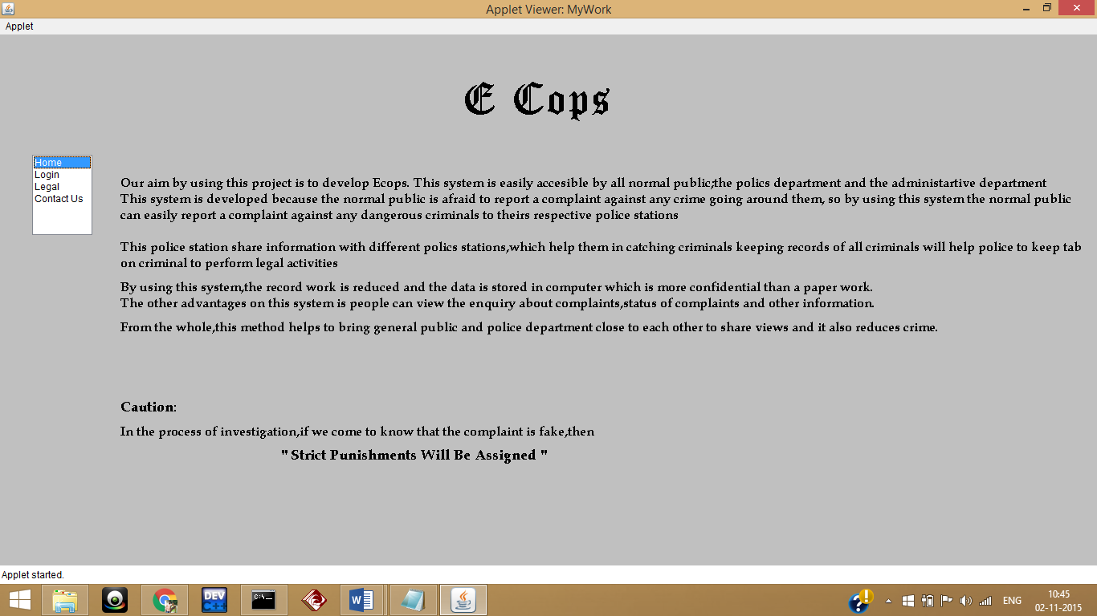

**2.Legal**

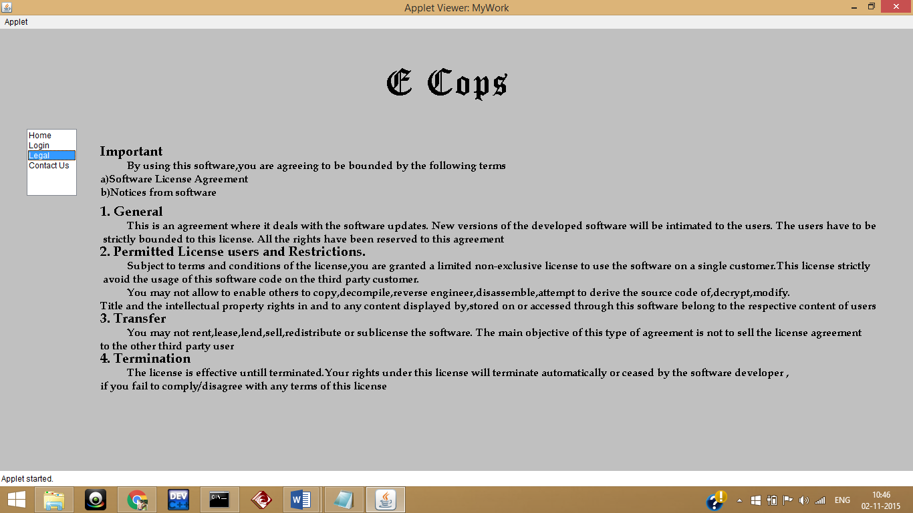

**3.Contact Us**

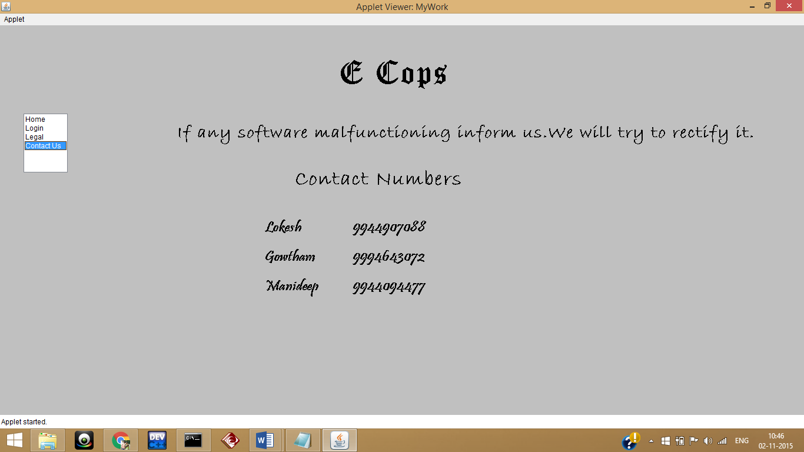

**4.Login Portal**

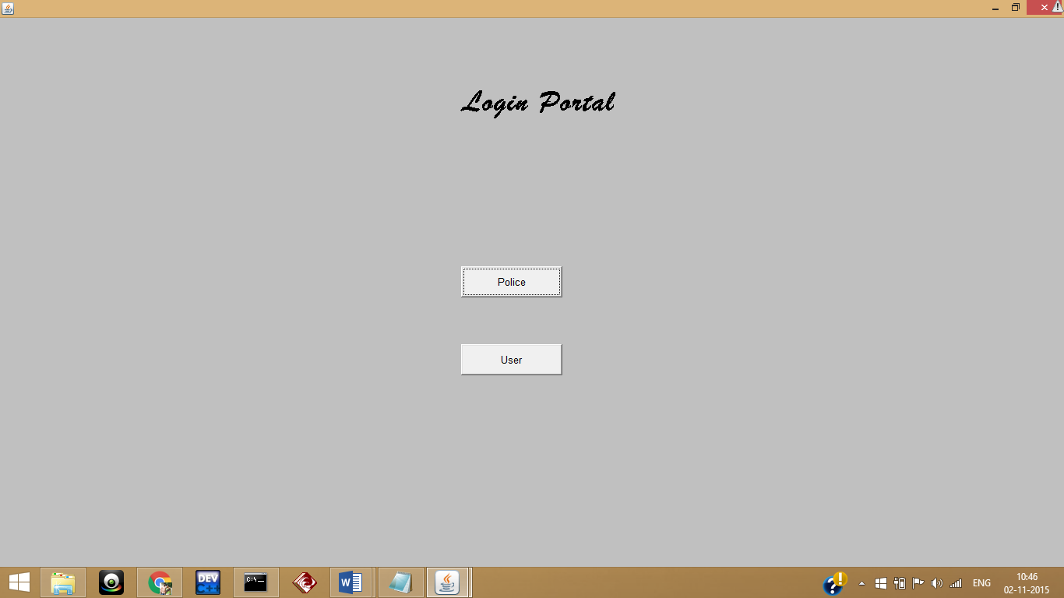

**5.User Registration**

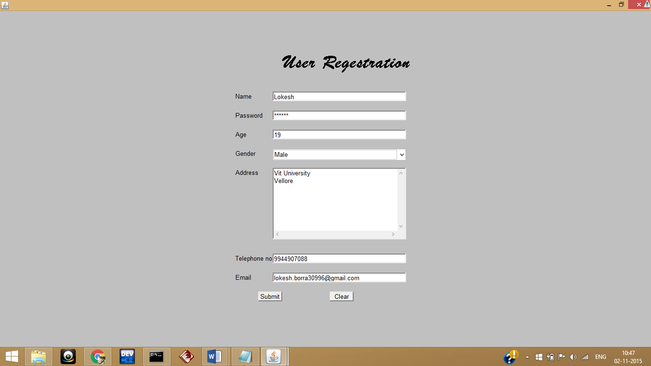

**6.User Login**

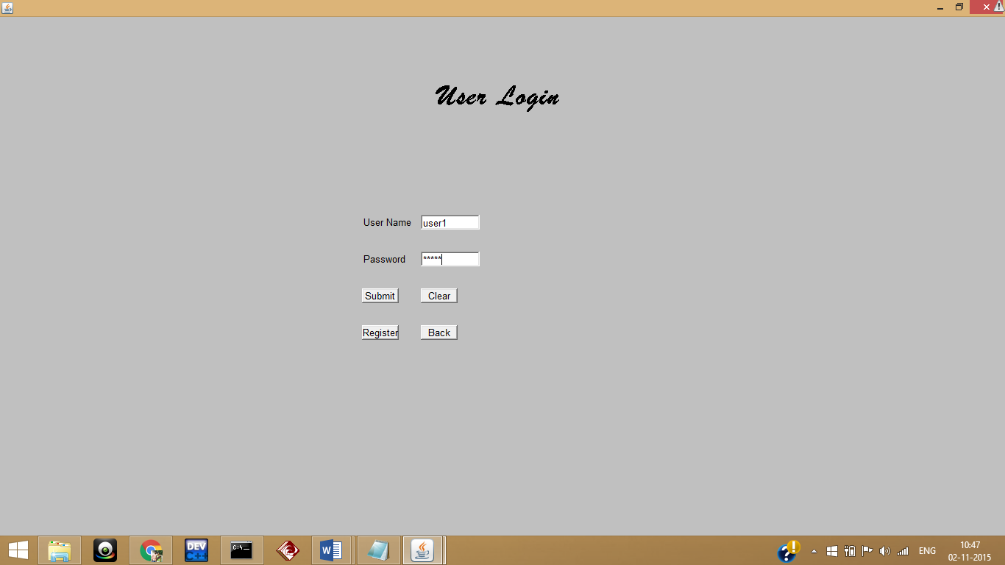

**7.User Logged In**

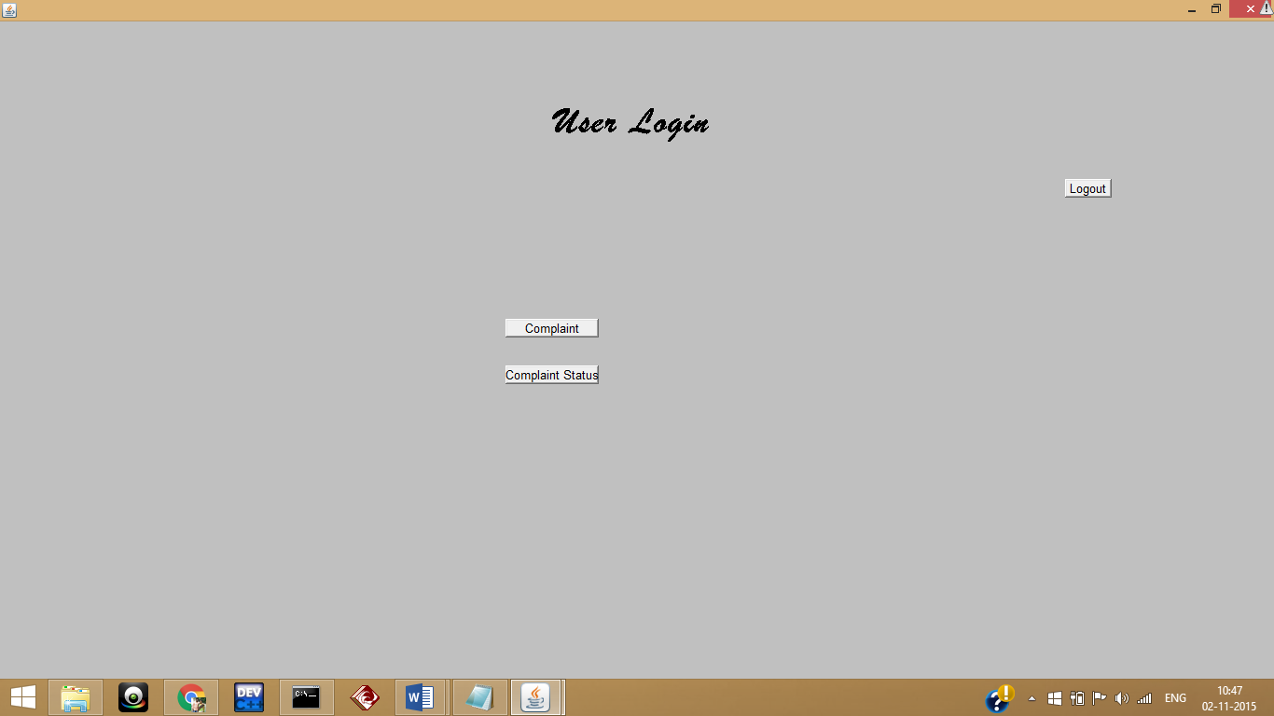

**8.Complaint form**

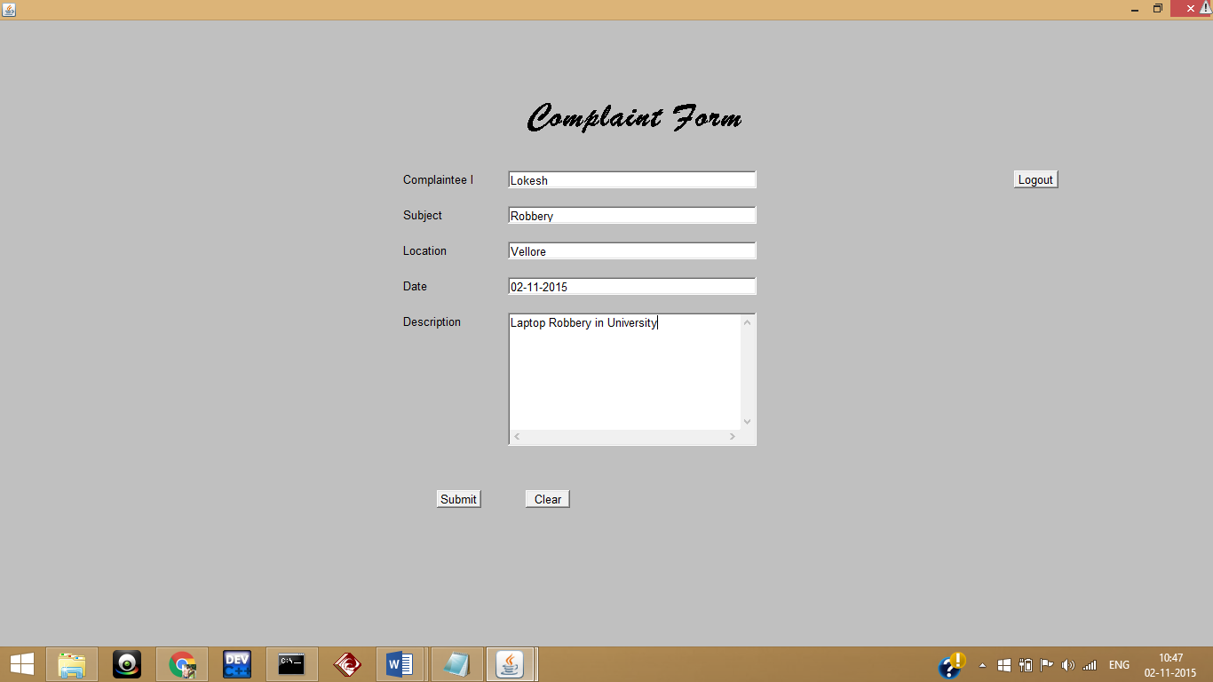

**9.Complaint Status**

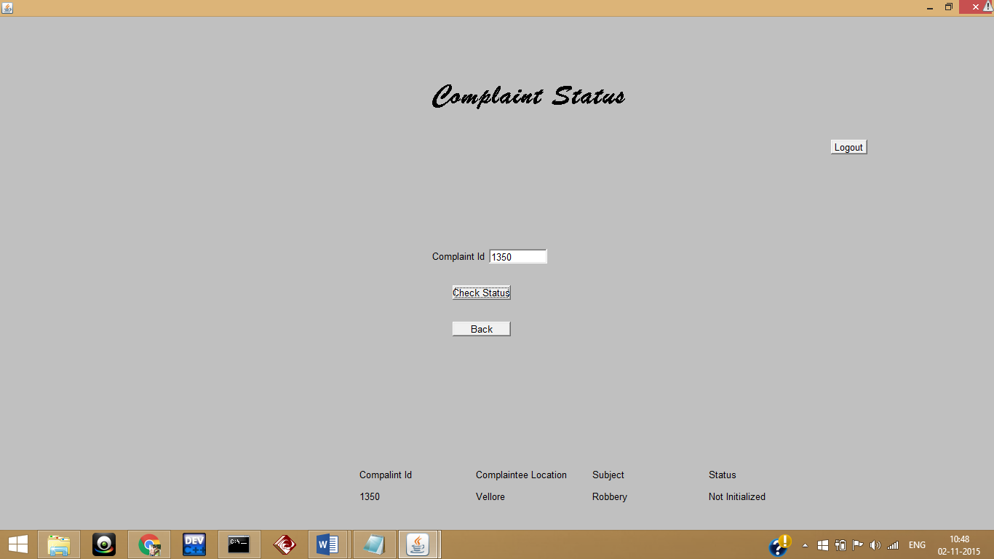

**10.Police Regestration**

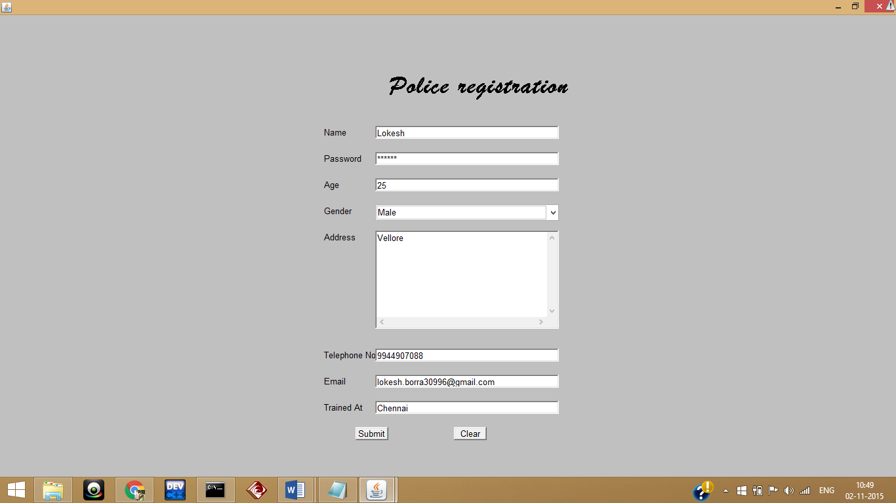

**11.Police Login**

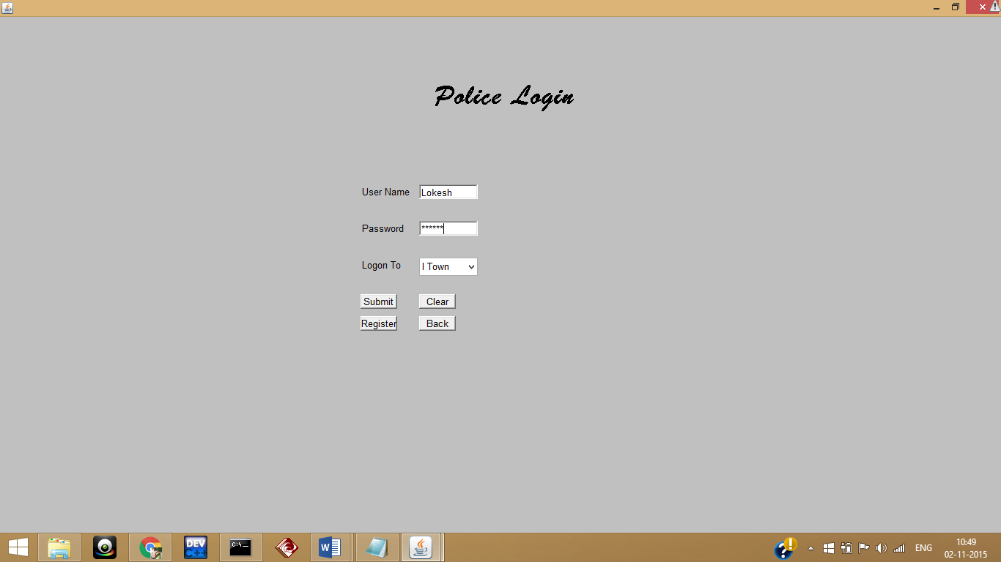

**12.Police Logged In**

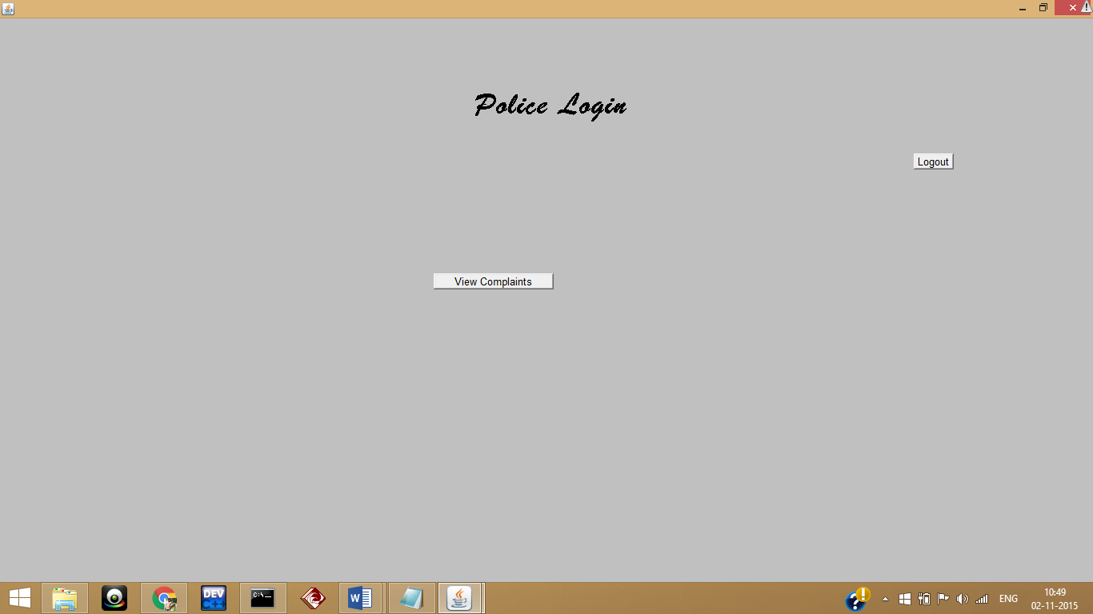

**13.View Complaint**

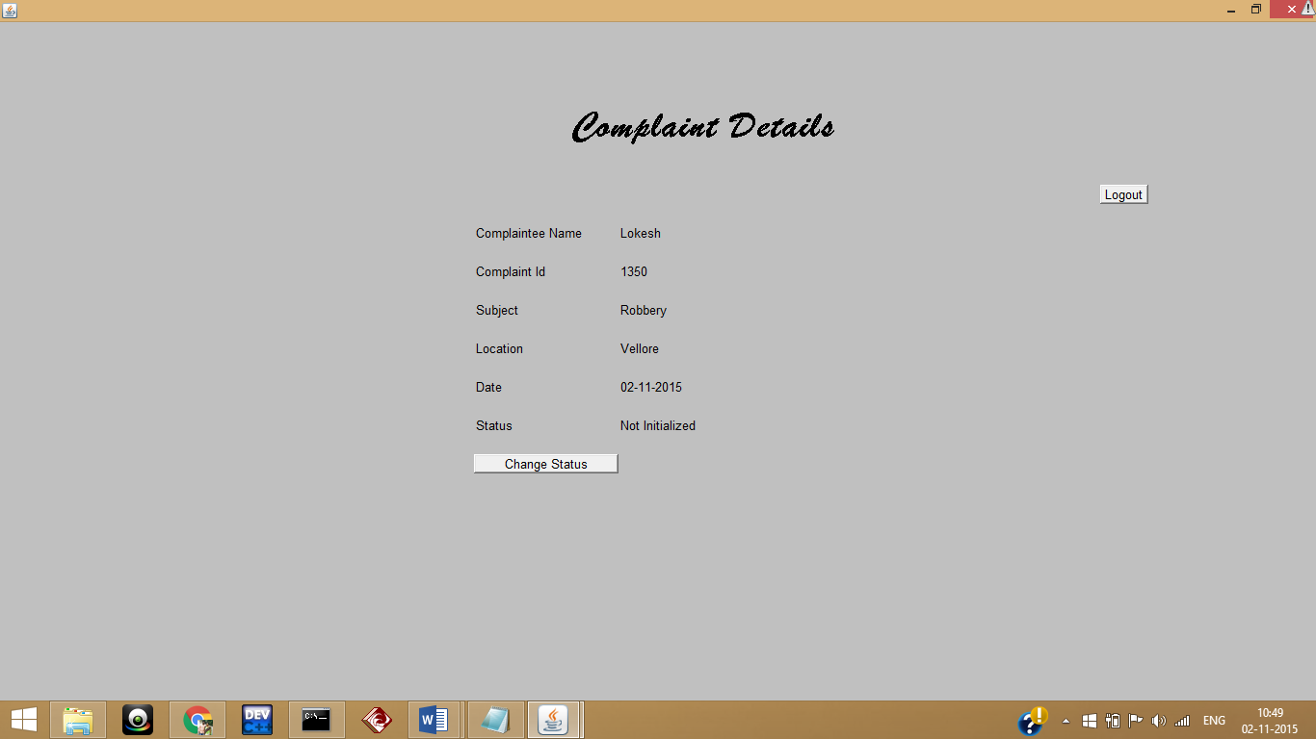

**14.Change Status**

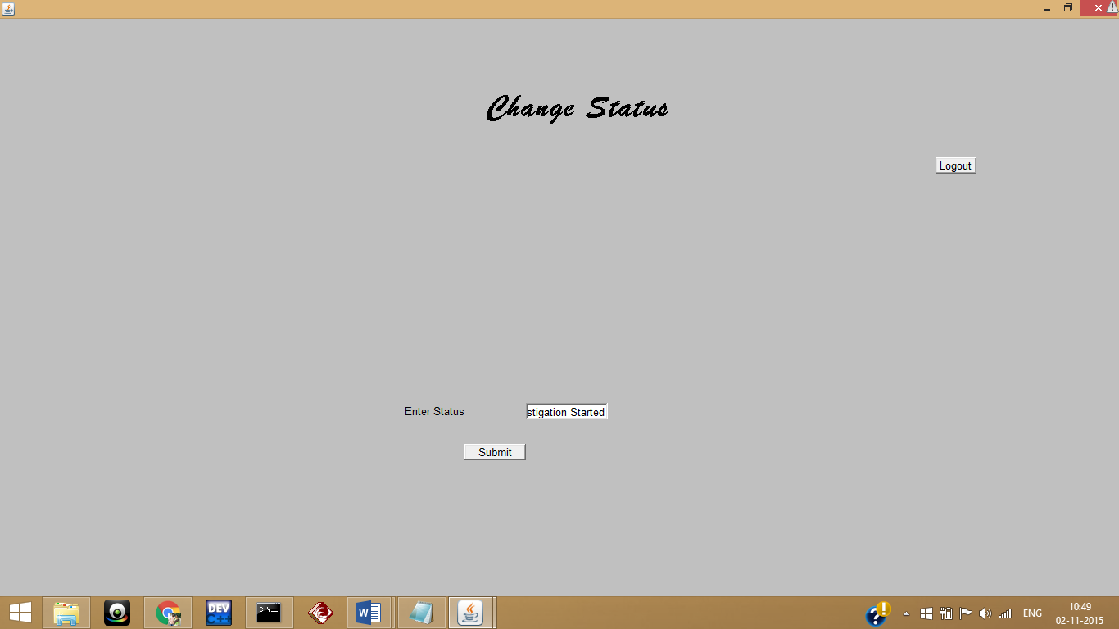

**15.View Complaint after change of Status**

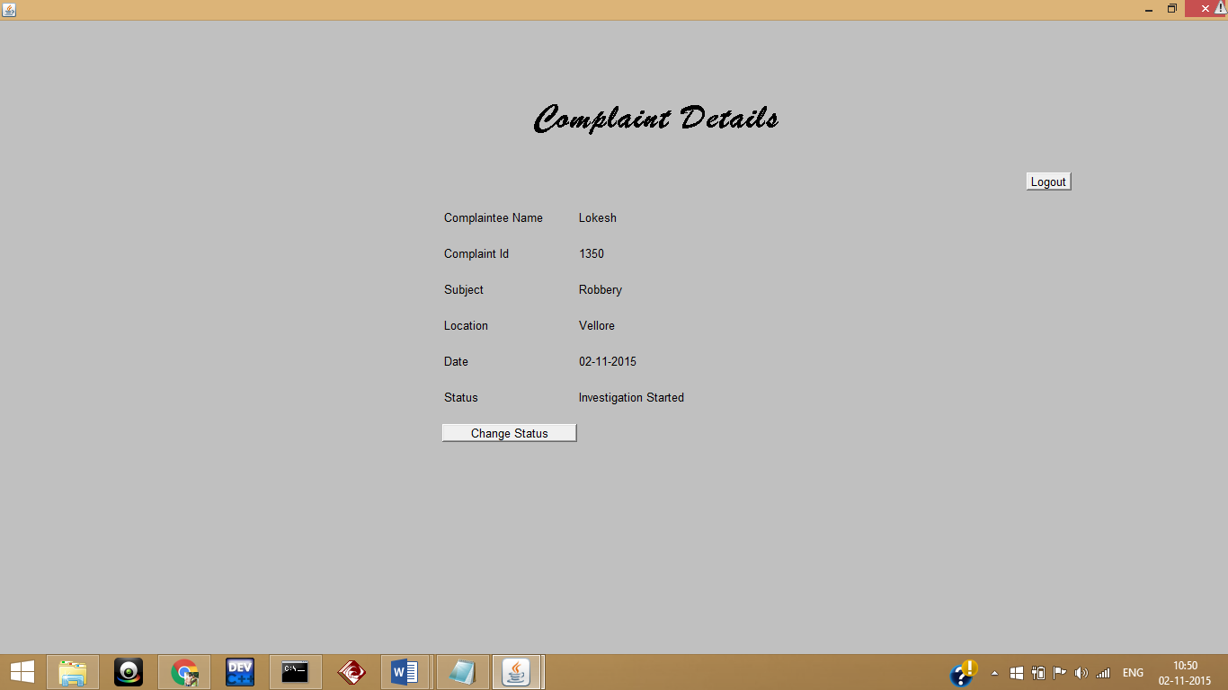

**16.View Status in User Login**

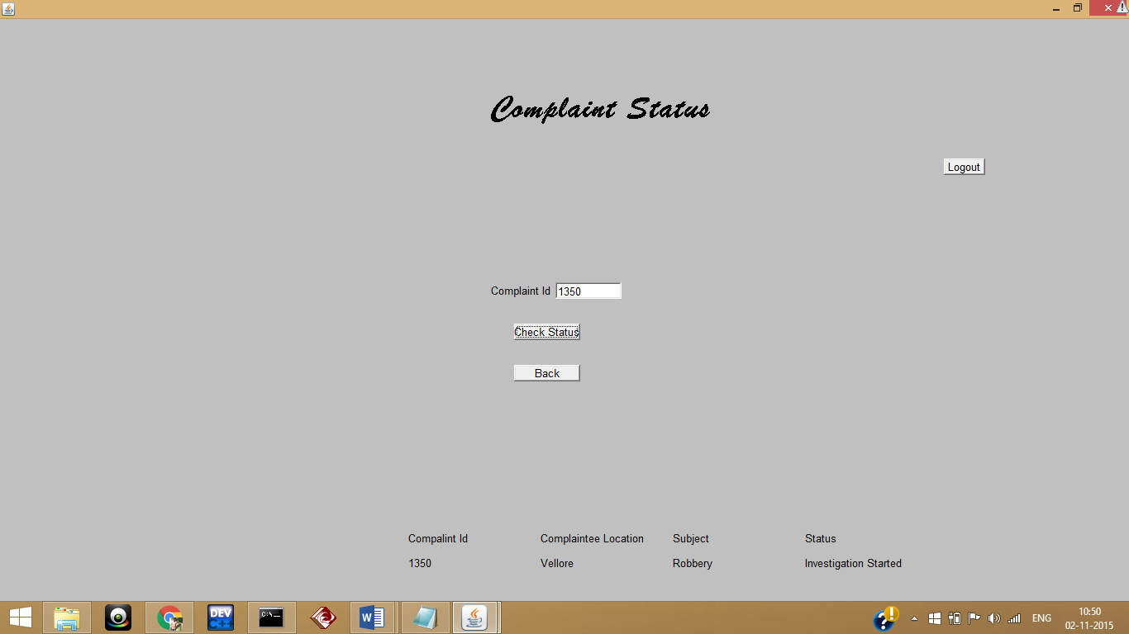

**Result:**

The technological benefits of ECOPS are to maintain information, monitor and enhance the performance of the department, to take a critical look at the existing system, processes and procedures of the department so as to identify and remove the redundancy.

The case registered at one police station can be tracked at any police station. This reduces the discretionary dependence of police. Once the case is registered the investigation and follow up activities relating to the case cannot be delayed.

All these factors have contributed to a higher moral of the police officials at all the levels in police department. This project result in great improvement in the organization’s functioning by reducing the effort spent by the general people.

**Through this project we can achieve:**

* Improve efficiency in police department
* Availability of online police service to citizens
* Speedy detection of crimes
* Duplication of work avoided
* Retrieval and access of data is easy
* Paper work is drastically reduced